September 16, 2019

**Assignment 1**

Operating System Concepts

**Submitted To**

*Mr. Umer*

**Submitted By**

*Usama Sarwar*

**FA17-BCS-090**

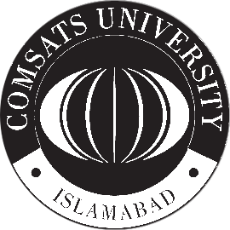

**COMSATS University Islamabad**

Sahiwal Campus